10 Reasons Why Physical Education is Important In Schools

[Leave a Comment](https://glentreeacademy.com/importance-of-physical-education/#respond) / [Education](https://glentreeacademy.com/category/education/) / By [glentreeacademy](https://glentreeacademy.com/author/glentreeacademy/)

We’ve often heard people stress the importance of physical education, how important it is really? As parents, we often place higher importance to grades and ranks however for your child to grow holistically it is important for you as a parent to teach them to have the right balance between academics and sports.

With everything being shifted into a hybrid model, kids need to destress from their screens and focus on their mind and body. Despite virtual classes, [Glentree Academy](https://glentreeacademy.com/) has made a constant effort to conduct virtual physical educational activities for their kids.

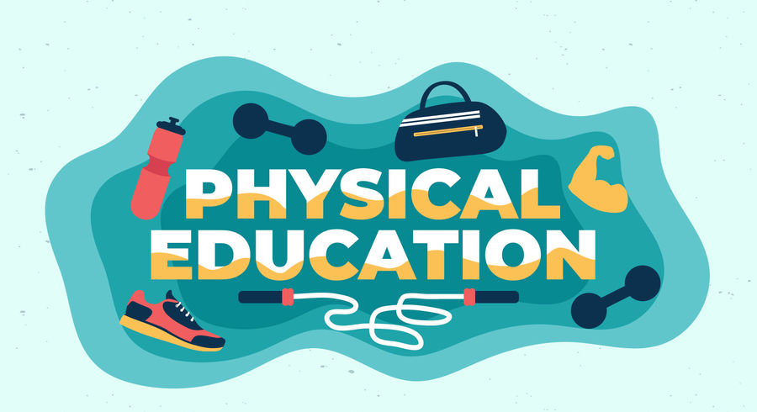

## **We must now move into understanding the importance of physical education?**

Let me list them down for you quickly;

1. Increased concentration and focus.
2. Fights child obesity.
3. Better Quality of Sleep.
4. Relieves Stress.
5. Reduces levels of depression and anxiety.
6. Increase leadership skills and teamwork.
7. Positive Body Image.
8. Self Discipline.
9. Boosts Confidence.
10. Develops Motor Skills and Improves Behaviour

## **INCREASED CONCENTRATION AND FOCUS**

It’s hard to deal with your child’s tantrums while studying or doing any other chores. Studies have proven that students who play sports or who are involved in physical or fitness activities have increased levels of concentration and focus. With this renewed energy and concentration levels it positively impacts on all arenas of their lives including academics. Students who are athletic in nature are highly alert and efficient and effective in academics.

## **FIGHTS CHILD OBESITY**

Times have definitely changed and that holds good for our food habits too. Children often get addicted to flashy junk foods, canned and processed foods, sodas and carbonated drinks. These foods are termed “unhealthy” and ultimately leads to child obesity. We all do understand the many health problems that are associated with the consumption of these unhealthy foods. Hence only with regular exercise implemented from childhood, a child will turn out to be a healthy individual.

## **BETTER QUALITY OF SLEEP**

It is a well-known fact that students who exercise regularly have a better quality of sleep. With decent levels of sleep, it increases a student’s concentration level and highly improves their attention span.

## **RELIEVES STRESS**

It is an undeniable fact that kids and teens today are under high pressure than anyone else. With their virtual classes, recurring assignments and being stuck within four walls only adds to more pressure. The only way from them to escape this pressure is to engage in physical activities. It helps them to take a break from their usual routine for a while and destress themselves.

## **REDUCES ANXIETY AND DEPRESSION**

Depression and anxiety have become two extremely common words for Gen-Z kids. These words have lost their original meaning and have turned as mere tags to brand kids. As parents, we often forget to understand that depression and anxiety come in many forms. One way to ensure that kids don’t fall into these traps is to ensure that they step away from their homes and step their foot in nature and perform some fitness activities. Every child needs to be physically active to keep their mental health on track.

## 

## **TEAMWORK AND LEADERSHIP SKILLS**

In order to be a leader, you must be a good team player. Only if an individual is able to cooperate and be a part of a great team, he or she will automatically be a great leader of a team. One way to instil these qualities of teamwork and leadership is to encourage children to participate in sports. It helps young people to improve their leadership skills and teaches them how to be spirited as a team or a community. Through physical exercises, students learn how to make and break bonds between their peers and this creates a healthy dynamic between the children. With teamplay, kids are more concerned not only about themselves but also their fellow mates and this brings about a community spirit amongst them. With values like these being sown into them at a very young age, they are sure to turn out to be great citizens of the country.

## **POSITIVE BODY IMAGE**

Body-shaming and defaming based on physical appearance is at its highest now. People have turned intolerant towards each other and pass harsh comments by making others feel insecure. It is highly important for everyone who promotes body image to promote physical activities as it is the only way through which an individual can look happy, feel good and right about themselves and their body. Especially women and girls have been constantly for their looks and appearance. Hence with this societal pressure to look in a specified way, physical activities are of utmost importance.

## **SELF DISCIPLINE**

The most important outcome of physical education is the discipline an individual acquires. Sports teaches children to implement this self control in all aspects of their life, from better controlling their emotions to being more self motivated with their studies.

## **BOOSTS CONFIDENCE**

Physical Education helps children to develop a sense of confidence in themselves. This can have a positive aspect in all areas of their life, such as their personal relationships and ability to integrate quickly and make friends, to think about their future goals.

## **DEVELOPS MOTOR SKILLS**

Sports and other physical activities help children **develop their motor skills** and strengthen their muscles. When fine motor skills are developed, through sports children will be more adept at handwriting or playing a musical instrument of their choice.

## **IMPROVED BEHAVIOUR**

Several experiments have shown us that through sports you can improve the behaviour of your child.



Now that we’ve understood the importance of physical education in schools.

## **What is the Need for Physical Education?**

There are several reasons why a student must involve in physical educational activities, they are;

1. It improves the learning aptitude of the students.
2. Improves cardiovascular endurance, muscular strength, flexibility, mobility, and body consumption.
3. Improves power, agility, reaction, time, balance, speed and coordination by use of all senses.
4. It develops the skills of the children.
5. Children learn and practise motor skills in a safe environment. This allows for satisfying and successful participation in physical activities like an individual and team sports.
6. Regular physical activity helps to release tension and anxiety. It also helps to build resilience and emotional stability.
7. As children master skills they become more confident in their abilities. When children are successful in a safe learning environment they become more confident, assertive, self-controlled, and independent.

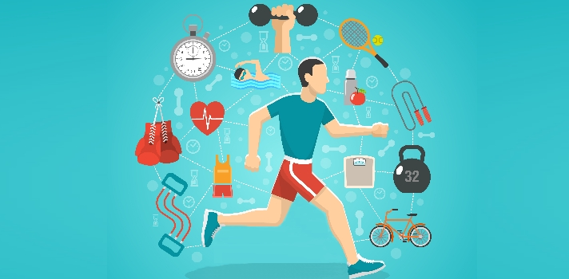

Now that you’ve understood the importance of Physical Education. It is clear that physical health is the pathway through which you can keep the mental health of your child on track. It plays an important role in the development of a student’s life. There are various factors that should be considered in the development of sports activities. One of these is the age of the student. It is important for a physical educator to help students to make the right choice of physical activities either now or in the future.